

Truststack LMS |
Learners Guide
  - Truststack Academy
A practical guide for people joining the learning community and learners using the Student LMS.
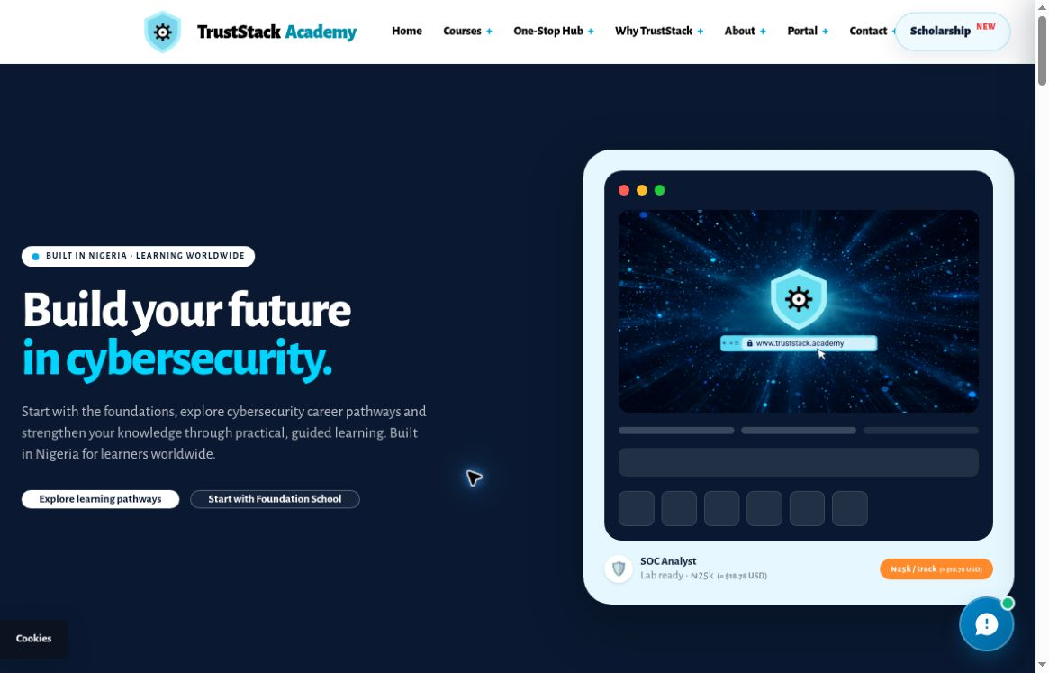
Truststack Academy website
Truststack Academy & Educational Services Ltd
October 2026 edition

Contents
Use the quick start if you are new. Existing learners can jump straight to their programme or to the tool they need.
Welcome and quick start 3
Choose your learning route 4
Join and enrol with the right expectations 5
Start Foundation School 6
Study and save in Foundation School 7
Join Computer Fundamentals 8
Explore the Computer Fundamentals workspace 9
Learn in Computer Fundamentals 10
Take the Computer Fundamentals final assessment 11
Use the CDPO study path 12
Retrieve a CDPO Certificate of Learning 13
Sign in to the Student LMS 14
Find your way around the workspace 15
Read lessons and use resources 16
Use the visual lesson player 17
Practise in labs and knowledge checks 18
Learn with Brainbox 19
Take part in course discussions 20
Understand your progress 21
Certificates and public verification 22
Download and share verified badges 23
Read updates and get help 24
Troubleshoot common problems 25
Glossary and useful links 26
About this edition This guide reflects the website and learner interfaces reviewed in October 2026. Your course access, available activities and assessment settings depend on your programme and account. Follow the current instructions displayed in your workspace.
Screenshots Images show the live website or an authorised demonstration workspace. Example progress values do not describe your account. Sample credentials and badge artwork are identified as examples wherever used.
Review scope Foundation’s registered study tools, the protected final assessment and unlocked badge sharing are reference workflows. They were not exercised on a live learner account for this edition. Follow the requirements shown in your own account.

Welcome and quick start
Truststack Academy offers several learning routes. Start by choosing the correct programme, then use its own registration or sign-in page. Keep your learner details safe so you can return to the same learning record.

If you are joining for the first time
1. Choose a route. Read the programme comparison on the next page: Foundation School, Computer Fundamentals, the CDPO study path or a career track.
2. Review the entry requirements. Check the programme page and current availability before registering or making any payment.
3. Use that programme’s registration process. Follow the fields and consent information on the page. Save the learner ID or private access details issued to you.
4. Return through the correct sign-in page. Open your programme, select a lesson or module, and check its learning activities.

If you are already a learner
1. Sign in to your programme. Career-track learners use their Assigned Learner ID and Registered Enrolment Email. Other programmes have separate sign-in flows.
2. Review updates. Read any programme or assessment notice shown in your workspace.
3. Choose your course and module. Work through the lesson, practical activities and checks available to you.
4. Confirm your progress. Use the programme’s completion controls and check its own learning record before moving on.

Before your first session
- Use an up-to-date browser and a reliable internet connection.
- Have your programme access details ready. Keep private passcodes out of discussion posts and screenshots.
- Allow time to read each activity’s instructions. A study activity, a progress marker and an issued credential are separate things.
Career-track payment status The current career-track checkout is labelled TEST only. It states that no money will be charged and no course access will be granted. Wait for the Academy’s live launch instructions before treating checkout as enrolment.

Choose your learning route
These routes have different entry methods, learning records and completion outcomes. Use the route that matches the programme you joined.
Route | How to enter | Learning record and outcome
Foundation School | Open Foundation School and use its registration or returning-learner flow. | Beginner self-study tools. Lesson progress, notes and attempts are stored in the browser. Export your study notebook.
Computer Fundamentals | Use its dedicated Register free or Learner sign-in page. The programme describes eligibility for people of Akwa Ibom origin. | 14 modules with progress saved to your learner account. Certificate eligibility includes programme completion, origin approval and a passed final assessment.
CDPO study path | Open the 30-day study path. Day 1 is public; enrolment confirmation unlocks later days. | Data-protection study with a separate enrolment and certificate-retrieval route. Study-path artwork is not professional certification.
Career tracks | Review the catalogue. Existing enrolled learners use Student LMS sign-in with learner ID and enrolment email. | Course and module workspace with saved LMS progress. Career badge sharing depends on an administrator-reviewed certificate association.

Explore the career tracks
The catalogue lists SOC Analyst, Digital Forensics, Threat Intelligence, Penetration Testing, Cloud Security, Governance & GRC, Malware Analysis and Security Engineering. Open a track to review its curriculum and the currently available learning route.
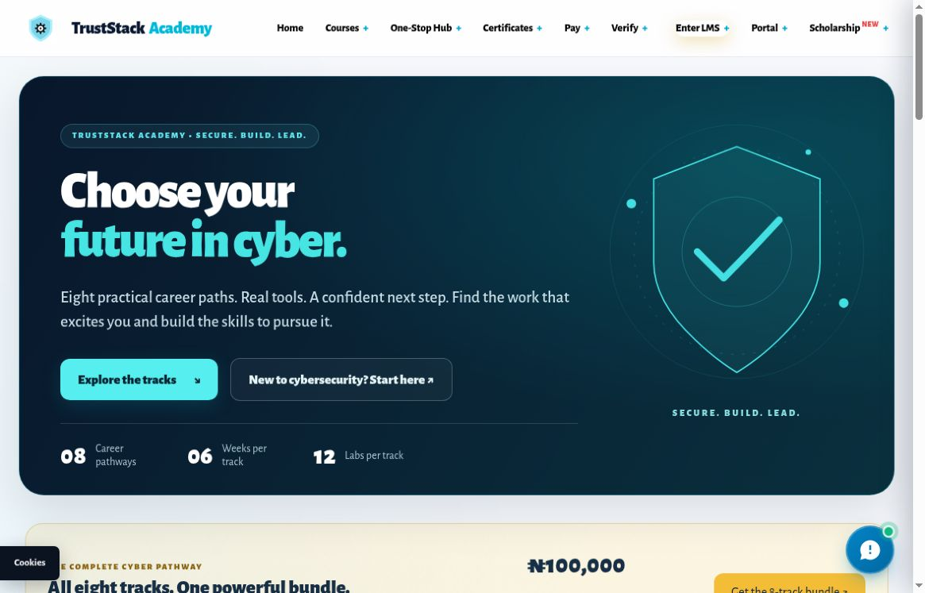
Figure 1. Career-track catalogue. Course descriptions and displayed availability can change.
Browse career tracks
Open Foundation School
Open Computer Fundamentals

Join and enrol with the right expectations
Public programme pages help you explore learning. Access to a restricted course requires the appropriate learner account and course entitlement; opening a course URL alone does not enrol you.

Career tracks
1. Open the catalogue. Choose a career track and read its public curriculum and access information.
2. Check the current enrolment status. The current Enroll Now route opens a test checkout.
3. Read the checkout warning. It explicitly says no money will be charged and no course access will be granted. Do not rely on a test submission for activation.
4. If you already enrolled, sign in. Use Student LMS or the existing-learner login link. Contact support if your expected course is missing.
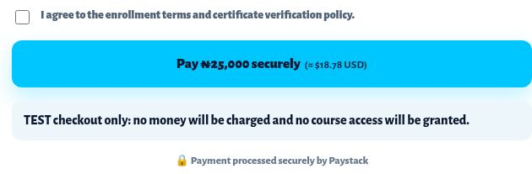
Figure 2. The current checkout explicitly says TEST only and grants no course access.

Foundation and Computer Fundamentals
Use the programme-specific registration links in the following pages. The Foundation registration area currently contains wording that refers to Computer Fundamentals. If the programme name or requested information does not match the course you intend to join, ask learner support before submitting.
Need guidance? Contact helpdesk@truststack.academy with the programme you want to join and the page you are viewing. Do not send a private passcode.

Start Foundation School
Foundation School is the beginner study route. Its interface describes 30 guided lessons, 60 knowledge checks and eight career paths. Save an exported copy of your study notebook. Notes and study progress are kept in the browser, even when you have a registered learner identity.
1. Open Foundation School. Use the Foundation School link from the academy website.
2. Choose Register & start learning. The registration interface offers New Learner Registration and Returning Learner Log In.
3. Review the form before submitting. The registration form asks for name, email, country, career interest and consent, with phone or WhatsApp optional. Confirm that the displayed programme matches your intention.
4. Save your Foundation Learner ID. Keep the ID issued by registration. Use the returning-learner flow when you come back.
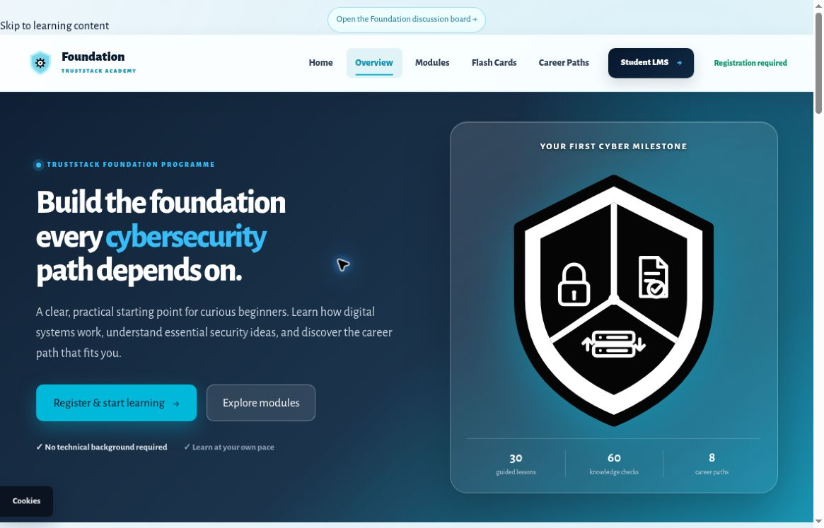
Figure 3. Foundation School entry page. Follow the programme label and current registration notice carefully.
Current wording issue The Foundation registration area was observed using Computer Fundamentals wording. Confirm your intended programme with support if this makes the registration unclear.
Returning learners Use Learner ID or Registered Email, then Log In to Discussion Board in the returning-learner panel. Complete any verification requested before posting.
Open Foundation School

Study and save in Foundation School
Once the learning tools are available, the Foundation workspace includes Overview, Learning path or Modules, Flash cards, Question bank, Career explorer, Glossary and My notebook.

Work through a lesson
1. Choose a lesson. Read the plain-language explanation, deeper explanation and context example.
2. Try the safe practice. Complete the exercise and review your own reflection.
3. Check your understanding. Answer the lesson checks, then compare with the model answer when offered. Both short checks must be correct before the lesson can be completed.
4. Complete and continue. Use Complete lesson, then Next lesson. Use Save for revision or Print this lesson when helpful.

Use the revision tools
- Flash cards help you recall ideas. Understood is a session marker and resets when the page closes.
- The Question bank offers topic, difficulty, search, practice and review controls. Use Submit and save result to record an attempt in your study record.
- The displayed 80% study target is a Foundation practice target. It is not a universal final-assessment pass mark.
- Career explorer helps you compare the available cybersecurity paths.

Protect your local notebook
1. Open My notebook. Review your notes, saved lessons, completion, attempts and interests.
2. Choose Export study notebook. Save the export somewhere you can find it again.
3. Keep the browser-storage limitation in mind. Changing device or browser, using private browsing, or clearing site data may leave your local study record unavailable. Export before clearing or resetting it.
Study record The notebook export is a self-study record. Foundation completion does not by itself establish professional certification.
Discussion access Registration may allow reading while posting remains read-only. If prompted, verify your email or discussion identity before trying to participate.

Join Computer Fundamentals
Computer Fundamentals is a separate free programme described for learners of Akwa Ibom origin. It has its own registration, learner sign-in, private passcode and progress record.
1. Open the programme page. Read the programme details and eligibility, then open Register free.
2. Complete the registration form. Use your full name as it should appear on your certificate. The form also asks for email, origin and residence details, experience and programme declarations.
3. Read and confirm the required declarations. Submit only information that accurately describes you and that you are ready to provide to the Academy.
4. Save the private passcode immediately. When registration succeeds, the current flow provides access details on screen. Use Copy passcode or Download access details, then confirm that you have saved the passcode before continuing.
Important The current registration flow issues your private passcode on screen. Do not depend on a registration email to recover it. Keep the downloaded access details private.

Return to learning
Use Learner sign-in on the Computer Fundamentals registration page. Enter your Email address and Your course passcode exactly, including hyphens, then choose Sign in to start learning. The page also accepts previously issued passcodes or passwords. Use Forgot your passcode? if needed.
Open Computer Fundamentals registration and sign-in
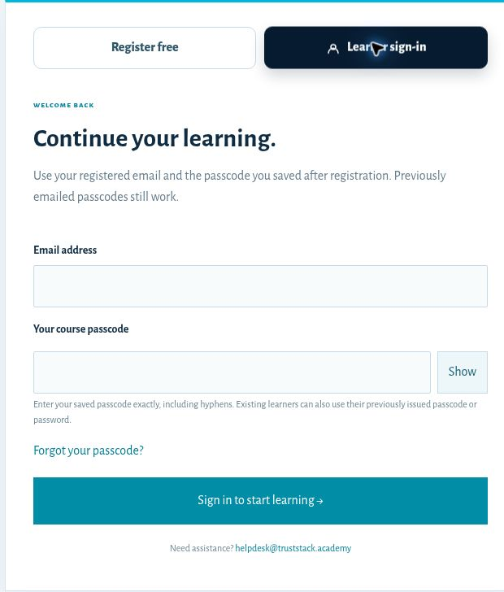
Figure 4. Computer Fundamentals uses registered email and its own private passcode.

If something does not match
If registration is closed, a required option is unclear or your details are rejected, stop and contact learner support. Share the page address and error message, without sending your private passcode.

Explore the Computer Fundamentals workspace
After signing in to your learner account, choose a module from the learning path. The public interactive demo below shows the workspace layout without opening or changing a learner record.
1. Select a module. Use the 14-module list on the left.
2. Choose a study activity. Use Visual lesson, Flashcards, Practice, Knowledge check, Discussion board or External learning Resources.
3. Open help when needed. Ask Brainbox provides help with the selected module. Download study guide PDF is available where shown.
4. Check your learning record. Use My progress & certificate to review module completion and certificate requirements.
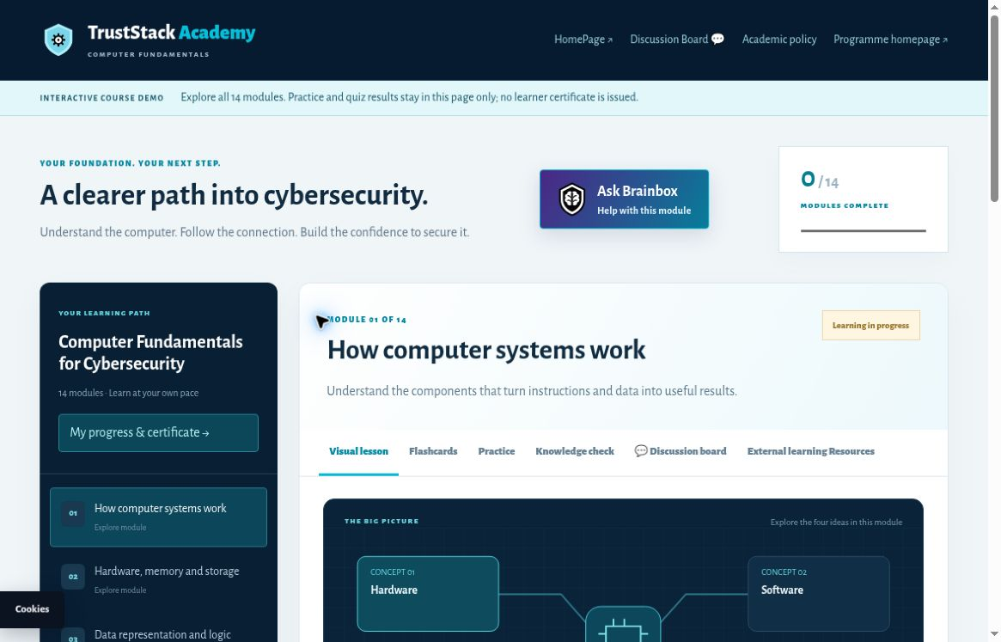
Figure 5. Public interactive demo; no learner record or credential. The banner identifies temporary demo activity.
Demo limitation Practice and quiz activity in the public demo stays in that page only. Document upload and certificate issuance are disabled there. Use your signed-in learner workspace for your own learning record.
Explore the public interactive demo

Learn in Computer Fundamentals
The Computer Fundamentals workspace contains 14 modules with lessons, visual study material, flashcards, practice, knowledge checks, discussion and external resources. Ask Brainbox or Help with this module provides contextual learning support.

Complete a module
1. Choose a module. Read the lesson and use its visual lesson or study guide where available.
2. Practise and review. Use flashcards, complete the practice response and work through the knowledge check.
3. Meet the module requirements. The displayed module has four questions and requires at least 70% plus a submitted practice response. Follow the instructions for your selected module; the sampled practice response requires at least 80 characters.
4. Review the learning record. Open My progress & certificate to see what remains.
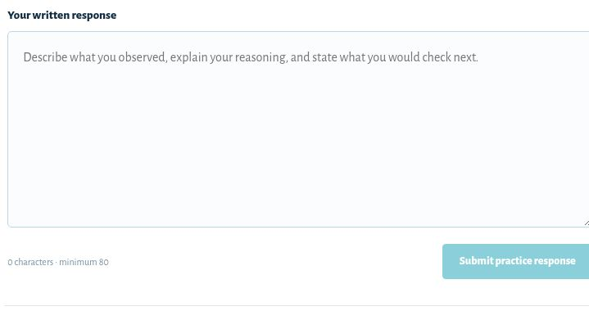
Figure 6. Public interactive demo; no learner record or credential. Practice uses a written response and a Submit practice response action.

Prepare for the final assessment
1. Complete all 14 modules. Check that the workspace records the required completion.
2. Finish the capstone response. Enter at least 300 characters for the capstone practice response, as required by the programme’s eligibility check.
3. Submit origin evidence when requested. The Certificate of Origin upload accepts PDF, PNG or JPEG up to 5 MB for private review.
4. Wait for approval and check assessment availability. Final eligibility depends on programme completion, capstone readiness, origin approval and the assessment being available.
Credential requirements Completing the modules alone does not issue the certificate. The programme also requires approved origin evidence and a passed final assessment.
Optional external lessons External learning Resources can open freeCodeCamp material on YouTube in a separate tab. Watching it is optional and does not automatically complete a module.
Open Computer Fundamentals learning

Take the Computer Fundamentals final assessment
The final assessment is a protected, server-timed process. Start only when you can complete it under the conditions shown on your assessment screen.

Before starting
- Check your eligibility and the current opening or scheduled availability.
- Read the current question count, duration, pass mark, attempt limit and any cooldown. These are configurable; the live assessment screen is authoritative.
- Use the correct Computer Fundamentals learner session and a reliable connection.
- If you need a time accommodation, use the support route before starting where possible.

During and after the assessment
1. Open the final assessment. Use the assessment action in your programme or the final-assessment page after signing in.
2. Review the conditions, then start when ready. Use the start action offered on the screen. The server controls assessment timing.
3. Work through the questions. Follow the interface instructions and allow answer saves to complete. If interrupted, return with the same account and use the resume option if offered.
4. Submit and review the outcome. Follow the submission and result instructions. If another attempt is allowed, respect the displayed cooldown and attempt limit.

Request assessment support
The assessment support flow accepts outage, reset, appeal and time-accommodation requests. Add a clear learner note explaining the problem, when it happened and the help you need. A request is subject to review; it is not an automatic reset, extension or change of result.
If access is blocked Return to My progress & certificate and check incomplete learning or pending origin review. If the status seems wrong, contact support rather than creating a second learner account.
Open Computer Fundamentals final assessment

Use the CDPO study path
The CDPO area is a separate, free 30-day data-protection study path. Day 1 is public orientation. Later study days and the exam require enrolment confirmation, even though the overview also displays no-sign-in wording.
1. Open the study path. Choose the Free CDPO course route or the CDPO study link.
2. Begin with Day 1. Use Read the lesson to explore the public orientation material.
3. Confirm enrolment for Day 2 onward. The gate asks for Full Name, Email Address, Mobile / WhatsApp and Commencement Date.
4. Review and submit the form. Use Confirm & Unlock Day 2 after checking your details and the page notice. Keep any registration details issued to you.
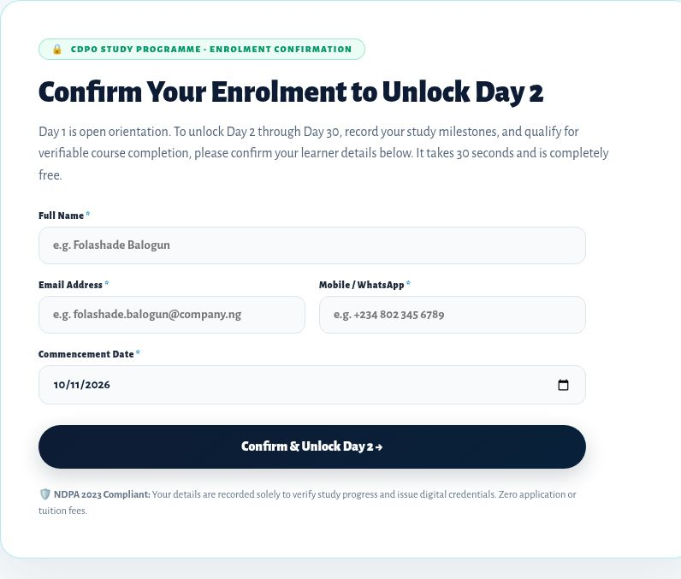
Figure 7. Live CDPO enrolment gate for Day 2. Day 1 remains public orientation.
Follow the access screen Use the actual enrolment prompt for Days 2-30. The overview’s no-sign-in wording does not remove that gate.
Credential wording The CDPO study-path badge represents the learning path. It does not, by itself, establish professional certification or completed skills.
Open CDPO study

Retrieve a CDPO Certificate of Learning
CDPO certificate retrieval uses its own registration ID and the email address used for CDPO enrolment. This is separate from career-track Student LMS sign-in and the public certificate-ID verifier.
1. Open the certificate-retrieval page. Use the CDPO certificate route.
2. Enter your CDPO registration ID. Copy it carefully into CDPO registration ID.
3. Enter your registered email. Use the same email address as your CDPO enrolment.
4. Choose Send access code. The page says a one-time code will be sent to your registered inbox. Continue using the instructions presented after that step.
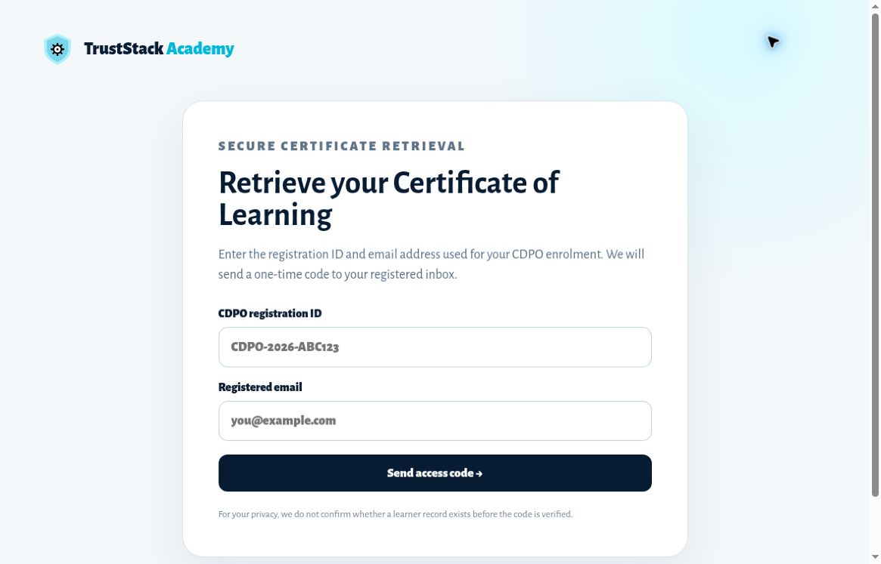
Figure 8. CDPO secure certificate-retrieval form. No code or learner record is shown.
Privacy The page does not confirm whether a learner record exists before the code is verified. Keep the one-time code private and enter it only in the retrieval flow you opened.
If the details do not work Check your CDPO registration ID and enrolment email. Contact support if you cannot find them or if retrieval remains unavailable.
Open CDPO certificate retrieval

Sign in to the Student LMS
Use the learner credentials issued for your enrolment. The Student sign-in page opens the learning workspace for your enrolled courses and saved progress.
1. Open the Student LMS. From the academy homepage, open Portal and choose Student LMS.
2. Enter your learner ID. Use the Assigned Learner ID field.
3. Enter your enrolment email. Use the Registered Enrolment Email field and the email address used for your enrolment.
4. Open your workspace. Choose Open Student LMS.
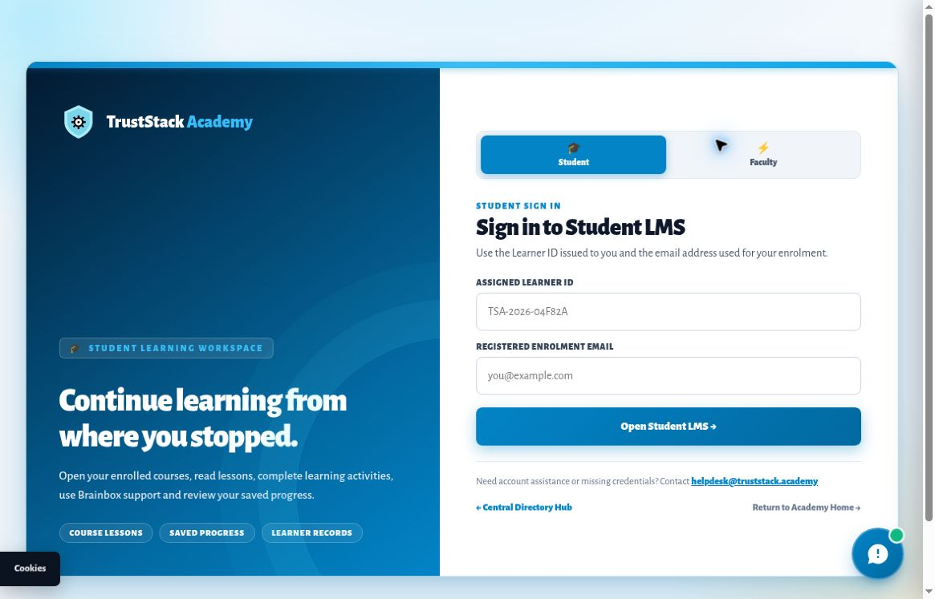
Figure 9. Student sign-in uses your assigned learner ID and registered enrolment email.
Missing credentials? The sign-in page lists helpdesk@truststack.academy for account assistance. Use Sign out in the workspace when you finish on a shared device.
Open Student LMS sign-in

Find your way around the workspace
The Learning workspace brings together your available courses, modules, lesson content and learning tools. The example below shows the SOC Analyst Track; your available learning and progress may differ.
1. Choose a course. Open My courses and select an available course.
2. Choose a module. Select a module in the list beneath the course selector.
3. Choose an activity. Use the Lesson, Visual lesson, Practical lab, Knowledge check, Discussion board or Resources tab.
4. Open supporting tools. Updates and Ask Brainbox are available from the workspace.
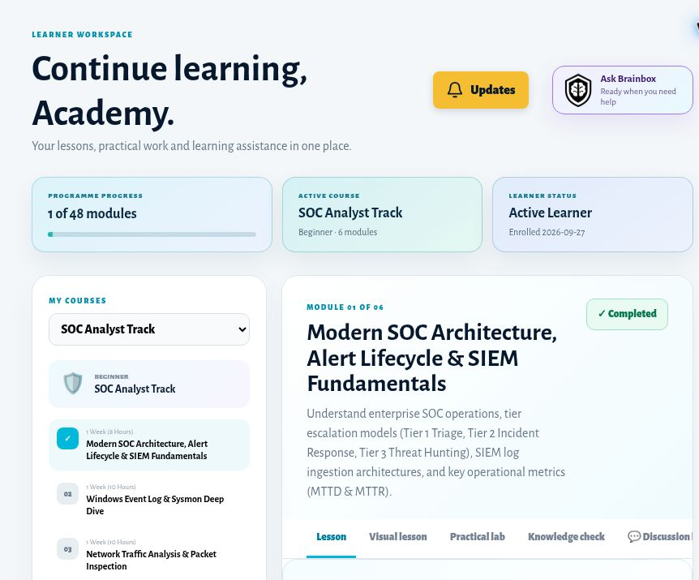
Figure 10. The workspace shows course selection, a module list, programme progress and learning activity tabs.
Your own record Progress values shown here belong to the demonstration workspace. Read the values displayed in your own account.

Read lessons and use resources
Career-track learning is organised by course and module. The selected module’s tabs bring its reading, visual lesson, practical work, recall practice, discussion and resources together.
1. Select your module. Use My courses and the module list in the Learning workspace.
2. Open Lesson. Read the learning material and any instructions for that module.
3. Use the related activities. Move to Visual lesson, Practical lab or Knowledge check as appropriate. These activities serve different learning purposes.
4. Open Resources. Follow the references listed for the module. The inspected SOC module links to sources such as NIST, MITRE and Wazuh.
5. Record completion when ready. Use Mark complete for an incomplete module. A completed module shows Completed. Check the progress save status before leaving.

Understand current availability
The inspected lesson video area is a coming-soon placeholder. Use the available text, visual lesson, resources and guided work. Do not assume that every advertised video or hosted lab is already live in your course.

Return to a module
Choose the module again from the list. Previous and Next module controls help you move through the course. Check that the selected course and module are the ones you intend to study before marking anything complete.
Completion and assessment The career-track Knowledge check observed here is recall practice with expandable questions and review explanations. Do not treat it as a submitted graded final assessment.
External resources External sites have their own content and availability. Return to the LMS after using a resource, and follow the Academy’s activity instructions for what to complete.

Use the visual lesson player
Visual lessons present the lesson as a silent chapter-based experience. They do not contain audio. You can follow the visual sequence, move between chapters and use the text or transcript alongside it.
1. Open Visual lesson. Choose the tab for the current module.
2. Navigate the lesson. Use Play, Previous, Next or the position slider. The chapter guide lets you select a specific chapter.
3. Adjust the display. Use Text, the playback-speed control or the expanded view when helpful. The available speed range is 0.75× to 2×.
4. Use the transcript. Read or download the chapter transcript where the control is provided.
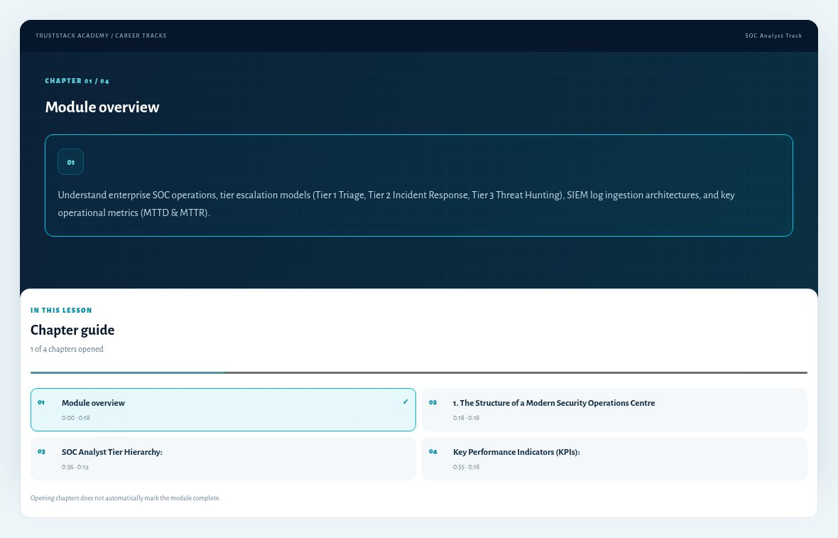
Figure 11. Expanded visual lesson with its chapter guide. The chapter indicator tracks opened chapters.
Progress distinction Opening chapters does not automatically mark the module complete. The player remembers its position in the current browser tab.

Practise in labs and knowledge checks
Use practical work to apply the lesson, then use recall questions to check your understanding. Read the environment and expected outcome before beginning.

Practical lab
1. Open Practical lab. Read the guided task, environment, estimated time and expected result.
2. Follow the guided instructions. Use only an authorised training environment and the values assigned for your activity.
3. Check the hosted-lab status. The inspected cloud environment is being prepared. Its launch control says Launch opens after testing; guided instructions remain available.

Knowledge check
1. Try the question from memory. Read the prompt before opening its explanation.
2. Expand and review. The inspected questions list options and a Review explanation. Compare the reasoning with your own answer.
3. Ask for a hint if needed. Brainbox can support recall practice. Return to the lesson if the explanation is still unclear.
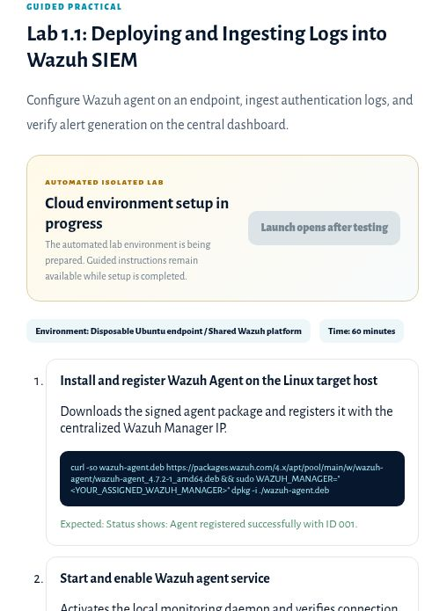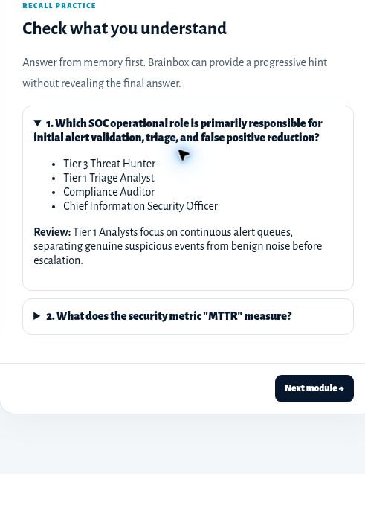
Figure 12. Left: guided practical work and disabled cloud-lab launch. Right: expandable recall practice with a review explanation.

Learn with Brainbox
Brainbox is the LMS learning assistant. Its panel identifies the current lesson and offers course-grounded help. Check that the Working with title matches the lesson you want to discuss.
1. Open Ask Brainbox. Use the button in your learning workspace.
2. Choose a mode. Select Explain for an explanation, Summarise for a recap, Quiz me for revision or Give a hint for help getting started.
3. Ask a focused question. Use Ask about this lesson, then choose Ask. For example: Explain the difference between these two terms in this lesson.
4. Check the source material. Review cited course material before relying on an answer. Use the close control to return to learning.
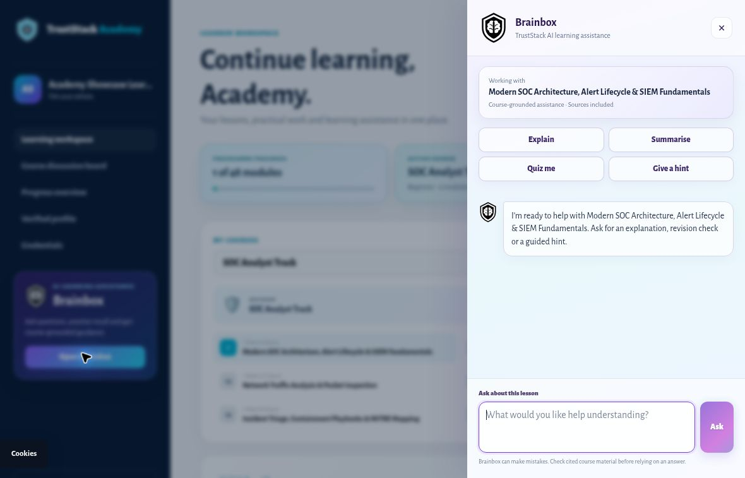
Figure 13. Brainbox provides four learning modes and a question field in a side panel.
Use your judgement. Brainbox can make mistakes. Its help supports your study; the course material and the instructions for your learning activity remain the reference.

Take part in course discussions
Discussion boards connect you with the learning community for your programme or track. Career-track boards require the appropriate learner sign-in and course access. Foundation posting may also require verified email or discussion identity.
1. Open the right board. Use Course discussion board in the workspace or the module’s Discussion board tab. Check the course name before posting.
2. Start a discussion. Choose Start a Discussion, then enter a clear Title.
3. Choose a category and write your message. Available categories include Module Q&A, Study Tips & Peer Notes, Career Transition and General Discussion.
4. Review before publishing. Check your message for private details, then choose Publish discussion. Choose Cancel to leave the composer without publishing.
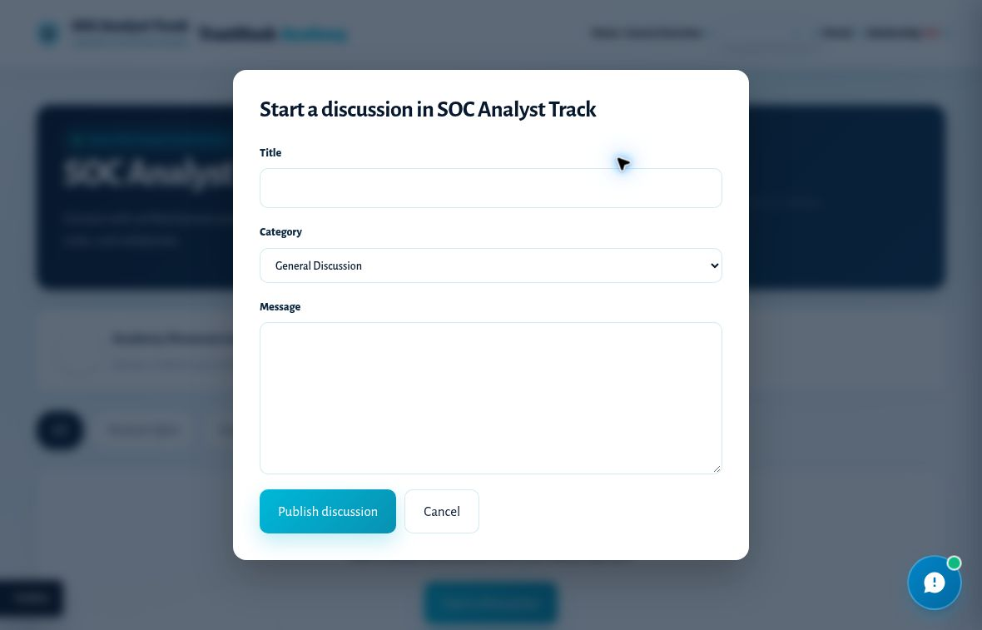
Figure 14. Discussion composer showing Title, Category, Message and the publish or cancel actions.

Make your post useful
Name the module or topic, explain what you tried and ask a specific question. Share only information you are comfortable making visible to the board. Keep passwords, private passcodes, personal documents and sensitive workplace data out of posts.
Replies and your own posts When an existing thread is available, use Reply to continue it. Where available, use Like or Load more discussions. Edit and Delete depend on your ownership and permissions. Review any deletion before confirming it.
If posting is unavailable Read the access message. Sign in to the correct programme, complete any requested discussion-identity verification, or contact support if your course access appears wrong.

Understand your progress
Different parts of the platform show different kinds of progress. Read the label before using a number to judge your completion.
Where you are | What the record means | What to do
Foundation School | Lessons, notes, bookmarks and attempts kept in the current browser. Flash-card understanding is session-only. | Use My notebook and export your study record.
Computer Fundamentals | Saved programme learning record across 14 modules, with separate origin-review and final-assessment states. | Open My progress & certificate and complete the listed requirements.
Career Student LMS | Module completion recorded in the current LMS progress system. | Use Mark complete when appropriate and check the save state.
Visual lesson player | Chapters opened and position in the current browser tab. | Use it to navigate; opening chapters does not complete a module.
Progress overview dashboard | A separate lesson/lab activity checklist. It can show different counts from the Student LMS. | Use the main Learning workspace record for current career-module progress; do not equate checklist ticks with certificates.

When two numbers do not match
The inspected demonstration account showed one module count in the LMS and a different lesson/lab checklist count in Progress overview. These screens do not measure the same activity. A difference does not, by itself, prove lost learning or certificate eligibility.

Check your verified profile
Use Verified profile in the career workspace, or open the public learner verifier and enter your Learner ID. This checks current programme participation. Use a certificate ID on the separate certificate verifier to check an issued credential.

If progress looks wrong
1. Confirm your account and programme. Make sure you signed in with the credentials for the learning route you used.
2. Check the exact item. Note the course, module and completion or save message shown.
3. Ask support with useful detail. Include the page address, item name, time and a privacy-safe screenshot. Do not send a private passcode.

Certificates and public verification
An issued certificate has a record that can be checked through the Academy’s verification service. Completing study activities, viewing a sample or downloading badge artwork is not evidence that a certificate has been issued to you.

Check your programme’s requirements
- Computer Fundamentals requires completed learning, approved Certificate of Origin review and a passed final assessment before certificate issuance.
- Career-track credential sharing depends on an administrator-reviewed certificate association with your learner record.
- Foundation notebook exports are self-study records; they do not establish professional certification.

Verify an issued certificate
1. Open certificate verification. Use the verification link supplied with your certificate, or open the public Verify page.
2. Enter the certificate ID exactly. Use the ID printed on the issued certificate. A learner ID and certificate ID serve different purposes.
3. Review the result. A valid result identifies the certificate, learner, track, issue date and registry match.
4. Use the available actions. Choose View Certificate. In the certificate window, use Print / Save PDF or Copy verification link.
Open certificate verification
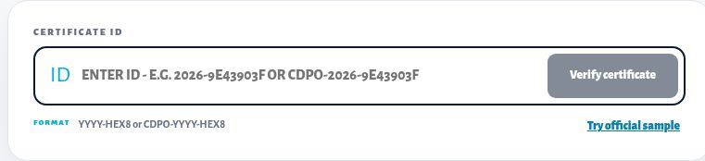
Figure 15. Public certificate verifier. Enter the ID from your issued certificate.

If verification fails
Check the ID for copying errors and make sure you used an issued certificate. If the record remains missing or does not match your details, contact support with the certificate ID and the visible error. Do not claim verified status while the mismatch is unresolved.
Samples and previews Try official sample demonstrates the verification flow. A sample or preview does not prove that you completed a programme or hold an issued credential.

Download and share verified badges
Badge artwork and a personalised, verified learner badge are different. Share the verification link with the badge so someone viewing it can check the issued record.

Career-track badges
1. Open Credentials. Use the workspace navigation to reach Credentials & sharing and Verified career badge.
2. Check eligibility. Sharing unlocks only after an administrator-reviewed certificate association. If the page says the learner record is not eligible, contact support if you believe the required certificate has already been issued.
3. Use the unlocked actions. Eligible records offer View verified certificate, Download personalized PNG and Copy verification link.
4. Share from your own account. Available social options are LinkedIn, Facebook, X and WhatsApp. Review the destination and message before posting.
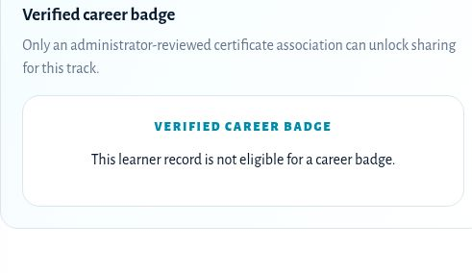
Figure 16. The observed locked state explains why career-badge sharing is unavailable.

Computer Fundamentals completion badge
After a valid Computer Fundamentals certificate is issued, its separate course-completion badge offers View badge, Download badge, Share badge, Copy verification link and Verify record. Use the actions shown in that programme’s certificate area.
If a share window does not open Use Copy verification link and paste it into your chosen platform yourself. Check that the link belongs to your issued record before posting.
Public badge gallery The gallery shows designs. The CDPO Study Path artwork identifies a learning path and does not represent certification or completed skills.

Read updates and get help
Check programme updates before beginning a learning session, especially when an assessment or service availability may affect your plans.
1. Open Updates. Use the bell or Updates control in the workspace.
2. Refresh if needed. Choose Refresh updates to check the current list.
3. Read the notice and any action link. Where a notice requests acknowledgement, use I have read this after reading it. Acknowledged indicates that response was recorded.
4. Return to learning. Choose Close & continue learning. No current alerts means the panel has no alerts to show at that time.
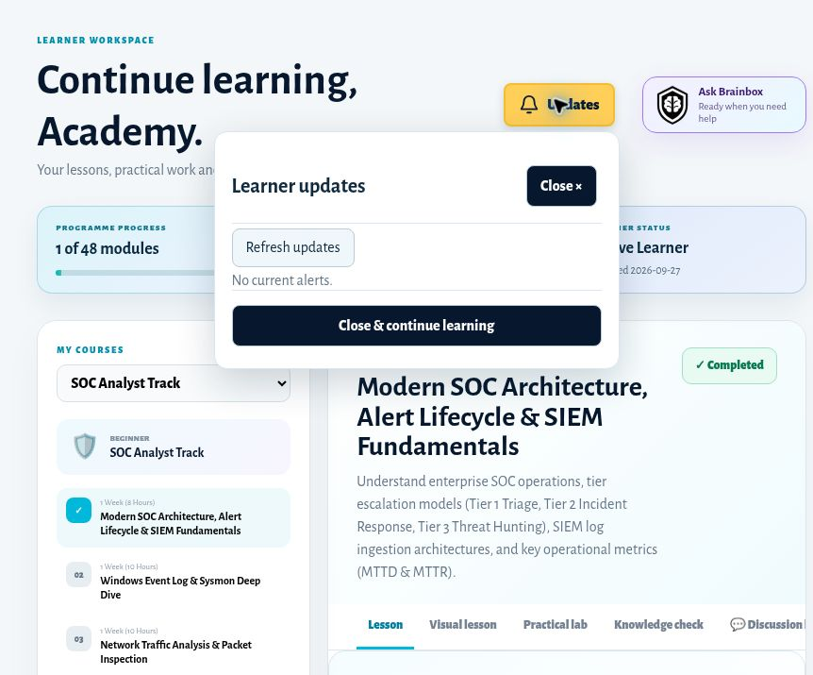
Figure 17. Learner updates panel in the demonstration workspace.

Contact learner support
Email helpdesk@truststack.academy or use the Contact page and choose Learner support. WhatsApp support is listed as +234 809 024 3111. For course-selection questions, choose Course guidance.
Contact form behaviour The website’s contact form prepares an email in your email application. Review and send that email to complete the enquiry; preparing it on the page alone does not send the message.
Open Contact
Email learner support

Troubleshoot common problems
What you see | What to check or do
Student LMS sign-in fails | Check Assigned Learner ID and Registered Enrolment Email. Use the correct programme’s sign-in page. Contact support if your credentials are missing.
A course or discussion is restricted | Check that the signed-in learner has access to that course. Use the correct course and programme; a public course URL does not grant access.
Foundation registration wording looks wrong | The inspected Foundation panel referred to Computer Fundamentals. Ask support to confirm the intended programme before submitting if unclear.
Foundation notes or progress seem missing | Return to the same browser and device if possible. Check your notebook export. Local records may be unavailable after site-data clearing or browser changes.
A lesson video is coming soon | Use the available lesson text, visual lesson and resources. The placeholder is not a working video player.
Cloud lab launch is disabled | Follow the visible availability notice. The inspected launch opens after testing; guided instructions remain available.
Brainbox cannot answer or seems wrong | Check the selected lesson and course access. Rephrase the question and consult cited course material. Retry later if temporarily unavailable.
Assessment entry is blocked | Review completion, capstone, origin approval and the displayed assessment window. Use programme support if the state appears wrong.
A career badge is locked | Check whether an issued certificate has been associated with your learner record by an administrator.
A social share window does not open | Use Copy verification link and post it manually after checking the destination.
The Contact form did not send anything | Open the prepared message in your email application, review it and send it there.

Send a useful support report
Include your programme, the relevant learner or certificate ID, course and module, page address, exact message, what you expected and when it happened. Attach only a screenshot with private data removed. Never include a private passcode, password or payment-card details.

Glossary and useful links
Term | Meaning in this guide
Learner ID | The identifier for your learner record. Use the ID issued by the relevant programme.
Enrolment email | The email address associated with your career-track enrolment and Student LMS sign-in.
Private passcode | Computer Fundamentals access information. Keep it private and save it when issued.
Course or track | A learning programme such as SOC Analyst or Digital Forensics.
Module or lesson | A unit within the selected programme. The completion rules depend on the programme.
Knowledge check | A learning or recall activity. Its scoring and completion role depend on the programme.
Brainbox | The contextual learning assistant available inside supported learning workspaces.
Entitlement | The course access associated with your learner account.
Certificate ID | The identifier for an issued certificate, used by the public verification service.
Verified badge | A shareable learner badge connected to an eligible issued credential.
Study notebook | Foundation’s browser-local record of notes, saved items and study activity.

Useful starting points
Academy home
Career-track catalogue
Foundation School
Computer Fundamentals
CDPO study path
Student LMS sign-in
Certificate verification
Contact and support

